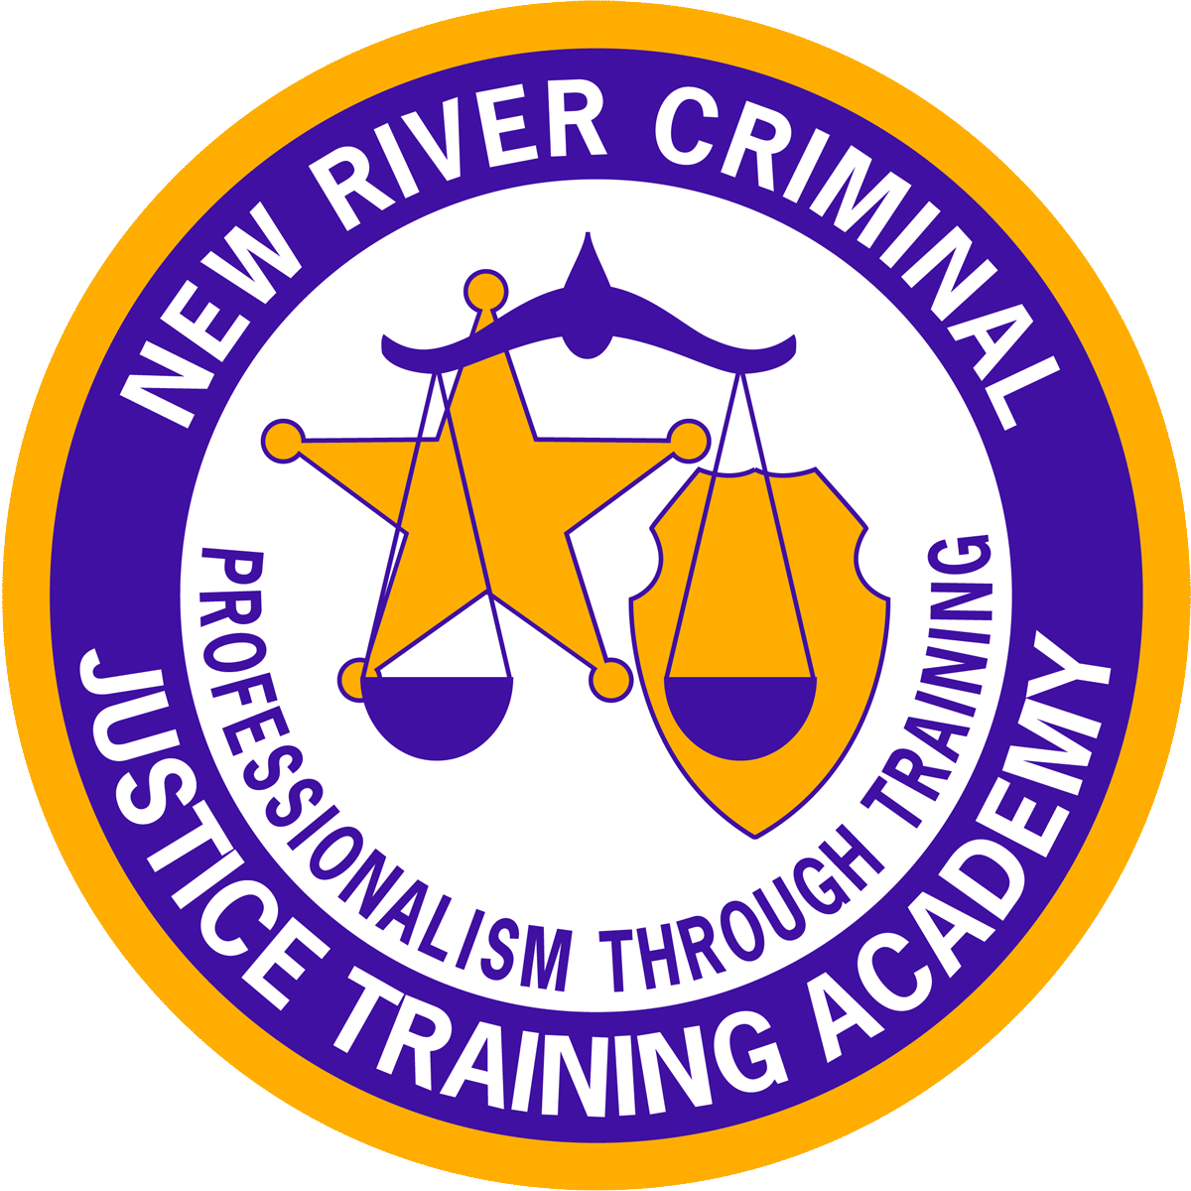

NRCJTA 2021 Training Calendar
Sign-up Booklet
Agency Name:_______________________________________

Preface
The 2021 Training Calendar is a listing of proposed training courses based upon identified needs through the Curriculum Development Committee. This group meets yearly, reviews each of our training programs, and puts together this list of training opportunities for the ensuing year. In an effort to serve our member agencies, we are asking that each agency complete their booklet and return it to the academy as soon as possible.
All agencies must enroll an actual student into a training program in lieu of using “hold four seats for such and such Sheriff’s Office, Police Dept., or Regional Jail. Substitutions will be accommodated, as training needs change and employee status changes without prior knowledge.
The Staff of the New River Criminal Justice Training Academy is committed to provide each agency with an improved line of communication on schools and training. Be assured of our willingness to meet training needs throughout the year.
For 2021, we will continue to use the same policies adopted in 2017 regarding attendance in classroom in-service programs. This means that students enrolled in classroom based programs will be required to complete the entire program (16hr./24hr./40 hour block. Those officers that only need partial hours, must attend one and day two workshops or complete their hours online. This will allow for increased efficiency in our in-service programs.
Specialty training programs will require 10 students to be conducted unless otherwise specified in the announcement. We must be good stewards of our financial resources. We will endeavor to provide a broad and comprehensive spectrum of training programs to accommodate most officers. As topics become available, we will make changes on our website and send out notices to all of our agencies.

Respectfully Submitted

Franklin R. Ferrell, Director

Below are the proposed classes for 2021 training year.
Back to HOME
Basic School Schedules | Date(s) | Location
Basic Entry Level Law Enforcement #81 | Jan 7, 2021 to June 17, 2021 | NRCJTA
Entry Level Jail Officer #84 | Feb.1, 2021 to April 9, 2021 | NRCJTA
Basic Entry Level Law Enforcement #82 | July 1, 2021 to Dec 16, 2021 | NRCJTA
Entry Level Jail Officer #85 | May 17, 2021 to July 30, 2021 | NRCJTA
Entry Level Jail Officers # 86 | Aug. 23, 2021 to Nov. 1, 2021 | NRCJTA
Entry Level Communications Officer #45 | March 8, 2021 to March 18, 2021 | NRCJTA
Entry Level Courtroom Security Civil Process | Jan. 25, 2021 to Jan. 28,2021 | NRCJTA
Entry Level Communications Officer #46 | October 12 to October 21, 2001 | NRCJTA
In-Service Programs
Combined Law Enforcement/ Court/Civil
Law Enforcement/Court Security/Civil Process In-Service Program. # | Oct 4, 2021 to Oct 7, 2021 | NRCJTA
Combined L.E./Jail/Court/Civil In-Service
Combined Law Enforcement/Jail/Court Security/Civil Process In-Service Program. (New Restrictions Apply). | Nov. 15, 2021 to Nov. 19, 2021 | NRCJTA
Combined Jail/Court/Civil In-Services
Jail/Court/Civil In-Service # | Feb.8, 2021 to Feb.10, 2021 | NRCJTA
Jail/Court/Civil In-Service # | June 28, 2021 to June 30, 2021 | NRCJTA
Jail/Court/Civil In-Service # | Oct. 25, 2021 to Oct. 27, 2021 | NRCJTA
Instructor Development Schools
General Instructor Development | Feb. 22, 2021 to Feb. 26, 2021 | NRCJTA
SFST Instructor Development |  | NRCJTA
Field Training Officer Development | Mar. 29, 2021 to April 1, 2021 | NRCJTA
Defensive/Control Tactics Instructor Pre-Test | April 5, 2021 to April 6, 2021 | NRCJTA
Defensive/Control Tactics Instructor Development | April 12, 2021 to April 15, 2021 | NRCJTA
Firearms Instructor Development | Aug. 2, 2021 to Aug. 6, 2021 | NRCJTA/CMR
 |  | NRCJTA/CMR
Advanced Firearms Instructor Development (Shotgun /Rifle Instructor) (You must have completed the Firearms Instructor Development School and you must have completed an approved rifle carrier course through your agency or the academy.) |  | NRCJTA/CMR
Defensive Driving Instructor Development | Aug. 30, 2021 to Sep. 3, 2021 | NRCJTA
Speed Measurement RADAR/LIDAR Instructor Development | May 3, 2021 to May 5, 2021 | NRCJTA
Field Training Officer Development | October 4 to October 8, 2021 | NRCJTA
General Instructor Development | September 7 to September 10, 2021 | NRCJTA
Patrol Rifle Instructor | November 8 to November 10, 2021
Instructor Re-Certification Programs will be completed online. (You must be pre-approved for recertification through your academy director). | Online re-certifications are available online quarterly | www.cvcja.org
FTO Recertification | March 30 to March 31, 2021 | NRCJTA
Firearms Instructor/General Instructor Recertification | Aug 4, 2021 | NRCJTA
Legal and Cultural Diversity Workshops (6 hours)
Legal Update and Cultural Diversity Workshop #1 | April 13, 2021 | NRCJTA
Legal Update and Cultural Diversity Workshop #2 | December 9, 2021 | NRCJTA
Dispatcher Programs | Date | Location
Communications Training Officer Train the Trainer |  | NRCJTA
Dealing with Difficult Callers |  | NRCJTA
Mental Health First Aid for Dispatchers |  | NRCJTA
Crisis Intervention for Dispatchers |  | NRCJTA
Specialty Programs
Crime Scene Photography |  | NRCJTA
Terrorism Investigations and Threat to Life Mitigation (8 hours FBI course) |  | NRCJTA
Basic Tactical Operations Training |  | NRCJTA
Advanced Search and Seizure |  | NRCJTA
The Reid Technique of Investigative Interviewing® for Child Abuse Investigations (you must register through John Reid and Associates). |  | NRCJTA
LE Basic Observer/Sniper Training Course (FBI Course) to be held at VA Army National Guard Center in Pulaski, VA. |  | VA Army National Guard Center in Pulaski, VA.
Recovery of Human Remains (FBI Course)
Dynamics in Supervision |  | NRCJTA
External Response to Active Shooter Events (ERASE) |  | NRCJTA
Mid-Manager/First Line Supervisor Leadership Development |  | NRCJTA
The Reid Technique of Interviewing and Interrogation® Training (you must register through John Reid and Associates). |  | NRCJTA
The Advanced Seminar on The Reid Technique of Interviewing and Interrogation® |  | NRCJTA

Basic School Schedules | Date(s) | Location
Basic Entry Level Law Enforcement #81 | Jan 7, 2021 to June 17, 2021 | NRCJTA
Entry Level Jail Officer #84 | Feb 1, 2021 to April 9, 2021 | NRCJTA
Basic Entry Level Law Enforcement #82 | July 1, 2021 to Dec 16, 2021 | NRCJTA
Entry Level Jail Officer #85 | May 17,2021 to July 30,2021 | NRCJTA
Entry Level Jail Officer # 86 | Aug. 23, 2021 to Nov.1, 2021 | NRCJTA
Entry Level Courtroom Security Civil Process |  | NRCJTA
Entry Level Communications Officer # 45 | March 8 to March 19, 2021 | NRCJTA
Name | SSN | School Type
[ ] ELD 45 [ ] BELLE 81 [ ] ELJ 84 [ ] BELLE 82 [ ] ELJ 85 [ ] ELCP/CS
[ ] ELJ 86

[ ] ELD 45 [ ] BELLE 81 [ ] ELJ 84 [ ] BELLE 82 [ ] ELJ 85 [ ] ELCP/CS
[ ] ELJ 86

[ ] ELD 45 [ ] BELLE 81 [ ] ELJ 84 [ ] BELLE 82 [ ] ELJ 85 [ ] ELCP/CS
[ ] ELJ 86

[ ] ELD 45 [ ] BELLE 81 [ ] ELJ 84 [ ] BELLE 82 [ ] ELJ 85 [ ] ELCP/CS
[ ] ELJ 86

[ ] ELD 45 [ ] BELLE 81 [ ] ELJ 84 [ ] BELLE 82 [ ] ELJ 85 [ ] ELCP/CS
[ ] ELJ 86

[ ] ELD 45 [ ] BELLE 81 [ ] ELJ 84 [ ] BELLE 82 [ ] ELJ 85 [ ] ELCP/CS
[ ] ELJ 86

[ ] ELD 45 [ ] BELLE 81 [ ] ELJ 84 [ ] BELLE 82 [ ] ELJ 85 [ ] ELCP/CS
[ ] ELJ 86

[ ] ELD 45 [ ] BELLE 81 [ ] ELJ 84 [ ] BELLE 82 [ ] ELJ 85 [ ] ELCP/CS
[ ] ELJ 86

[ ] ELD 45 [ ] BELLE 81 [ ] ELJ 84 [ ] BELLE 82 [ ] ELJ 85 [ ] ELCP/CS
[ ] ELJ 86

[ ] ELD 45 [ ] BELLE 81 [ ] ELJ 84 [ ] BELLE 82 [ ] ELJ 85 [ ] ELCP/CS
[ ] ELJ 86

In-Service Programs
Combined Law Enforcement/ Court/Civil
Combined Law Enforcement/Jail/Court Security/Civil Process In-Service Program. (Restrictions Apply)#2001 |  | NRCJTA
Combined Law Enforcement/Jail/Court Security/Civil Process In-Service Program. (Restrictions Apply).#2012 |  | NRCJTA
Combined Jail/Court/Civil In-Services
Jail/Court/Civil In-Service #2002 |  | NRCJTA
Jail/Court/Civil In-Service #2006 |  | NRCJTA
Jail/Court/Civil In-Service #2011 |  | NRCJTA
Legal and Cultural Diversity Workshops (6 hours)
Legal Update and Cultural Diversity Workshop #1 |  | NRCJTA
Legal Update and Cultural Diversity Workshop #2 |  | NRCJTA
Dispatcher In-Service Programs | Date | Location
Communications Training Officer Train the Trainer |  | NRCJTA
Dealing with Difficult Callers |  | NRCJTA
Mental Health First Aid for Dispatchers |  | NRCJTA
Crisis Intervention for Dispatchers |  | NRCJTA
NAME | SSN | School Type
NAME | SSN | School Type

Instructor Development Schools
General Instructor Development |  | NRCJTA
SFST Instructor Development |  | NRCJTA
Field Training Officer Development |  | NRCJTA
Defensive/Control Tactics Instructor Pre-Test |  | NRCJTA
Defensive/Control Tactics Instructor Development |  | NRCJTA
Firearms Instructor Pre-Qualification |  | NRCJTA/CMR
Firearms Instructor Development |  | NRCJTA/CMR
Advanced Firearms Instructor Development (Shotgun /Rifle Instructor) (You must have completed the Firearms Instructor Development School and you must have completed an approved rifle carrier course through your agency or the academy.) |  | NRCJTA/CMR
Defensive Driving Instructor Development |  | NRCJTA
Speed Measurement RADAR/LIDAR Instructor Development |  | NRCJTA
Name | SSN | School Type
Specialty Programs
Crime Scene Photography |  | NRCJTA
Terrorism Investigations and Threat to Life Mitigation (8 hours FBI course) |  | NRCJTA
Basic Tactical Operations Training |  | NRCJTA
Advanced Search and Seizure |  | NRCJTA
The Reid Technique of Investigative Interviewing® for Child Abuse Investigations (you must register through John Reid and Associates). |  | NRCJTA
LE Basic Observer/Sniper Training Course (FBI Course) to be held at VA Army National Guard Center in Pulaski, VA. |  | VA Army National Guard Center in Pulaski, VA.
Recovery of Human Remains (FBI Course)
Dynamics in Supervision |  | NRCJTA
External Response to Active Shooter Events (ERASE) |  | NRCJTA
Mid-Manager/First Line Supervisor Leadership Development |  | NRCJTA
The Reid Technique of Interviewing and Interrogation® Training (you must register through John Reid and Associates). |  | NRCJTA
The Advanced Seminar on The Reid Technique of Interviewing and Interrogation® |  | NRCJTA
Name | SSN | School Type
Name | SSN | School Type

